|  |  |
| --- | --- |
|  | **BAHRIA UNIVERSITY,**  **(Karachi Campus)**  *Department of Software Engineering*  **Quiz # 02 – Fall 2023** |

COURSE TITLE: **Formal Methods in Software Engineering** COURSE CODE: [**SEN -**](http://moodle.bimcs.edu.pk/course/view.php?id=291) **323**

CLASS: **BSE – 5B** SHIFT: **Morning**

INSTRUCTOR: **Engr. Ammarah Khalid** DATE: **25th Oct 2023**

MAX. MARKS: **6 Marks** TIME: **20 Mins**

**STUDENT NAME: __________________________ REG # ________________**

**QUESTION # 01:** Convert the given informal specification to formal specification  **[CLO 2]**

**Seat Allocation:** A system that records allocation of seats to passenger in an airplane. Note that a seat may be booked to only one person, but a person may book many seats

The types involved here are the set of all possible persons, called PERSON, and the set of all seats on this airplane,

[PERSON] The state the set of all possible uniquely identified persons

[SEAT] the set of all seats on this airplane

|  |  |
| --- | --- |
| **State Space Schema** | **Write an operation to allow a person p?, to book the seat s?.** |
| **Write an operation to discover the owner of a seat**  REPLY ::= yes I no |
| **Write a schema to handle errors on making a** **booking**  RESPONSE ::=OK IalreadyBooked |

**QUESTION # 02:**  Convert the given informal specification to formal specification…………. **[CLO 2]**

Database of films is specified by means of a schema for recording information about films. This database is capable of holding information about who directed a particular film and about the writer of the film's screenplay. Every film in the database must have a director and writer associated with it. Provision has been made for films that are directed by several people and written by more than one person.

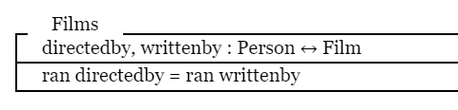

**Specify the operation of adding films to the database concerning a film with only one director and only one writer**

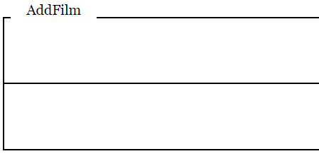

**Specify an operation to find out all the films directed by a particular individual:**

|  |  |
| --- | --- |
|  |  |